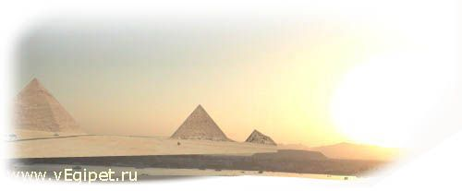
09.04.06 по 18.04.06 г. (10дн./9ноч.)
Отель, категория | ** | Пит | DBL | SGL | TRPL | CHD 0-6 | CHD 6-12 | HB/  ALL
HYATT REGENCY | 5* | BB | 1508 | 1899 | 1299 | 420 | 659 | 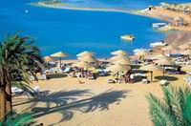  288
RITZ CARLTON | 5* | BB | 1499 | 1892 | 1440 | 420 | 420 | 225
LAGOUNA VISTA | 5* | ALL | 1223 | 1418 | 1199 | 420 | 420
Magic Life Sharm std | 5* | MAI | 1235 | 1382 | 1059 | 420 | 619 до 15
REEF OASIS | 5* | ALL | 1198 | 1470 | 1168 | 420 | 420
SOFITEL | 5* | BB | 1024 | 1285 | N/A | 420 | 420 | 162
NOVOTEL | 5* | BB | 942 | 1190 | 923 | 420 | 420 | 162
RADISSON SAS | 5* | BB | 674 | 772 | 654 | 420 | 420 | 90
RADISSON SAS GOLDEN | 5* | ALL | 889 | 1026 | 870 | 420 | 420
SHERATON main | 5* | BB | 1233 | 1575 | 1199 | 420 | 631 |   189
MARRIOTT BEACH | 5* | BB | 978 | 1174 | 929 | 420 | 532 | 180
CROWNE PLAZA | 5* | BB | 822 | 1017 | 799 | 420 | 420 | 135
TROPICANA GRAND OASIS | 5* | ALL | 939 | 1037 | 910 | 420 | 420
TROPICANA GRAND AZUR | 5* | ALL | 1046 | 1192 | 1016 | 420 | 420
SUNRISE ISLAND VIEW | 5* | ALL | 999 | 1277 | 974 | 420 | 420
SUNRISE ISLAND GARDEN | 5* | ALL | 905 | 1111 | 876 | 420 | 420
INTERCONTINENTAL | 5* | BB | 890 | 1086 | 871 | 420 | 420 | 180
SAVOY SHARM pool view | 5* | BB | 928 | 1124 | 899 | 420 | 420 | 162
IBEROTEL PALACE | 5* | HB | 977 | 1222 | 948 | 420 | 420 | 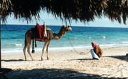
GRAND ROTANA DELUXE | 5* | BB | 941 | 1186 | 928 | 420 | 420 | 126
RENAISSANCE | 5* | BB | 812 | 1017 | 773 | 420 до 4 | 548 | 171
NAAMA BAY | 5* | HB | 1032 | 1341 | 1012 | 420 | 420
Domina Coral Bay Oasis | 5* | BB | 675 | 763 | 655 | 420 | 420 до 13 | 63
ROYAL PLAZA | 5* | HB | 821 | 967 | 799 | 420 | 420
CLUB EL FARAANA | 4* | ALL | 927 | 1074 | 898 | 420 | 420
PALMYRA RESORT | 4* | ALL | 741 | 859 | 722 | 420 | 521 до 14
SETI SHARM std | 4* | HB | 693 | 799 | 674 | 420 | 420 | 90
HOLIDAY INN | 4* | HB | 807 | 1011 | 787 | 420 | 420
NORIA RESORT | 4+* | HB | 762 | 879 | 742 | 420 | 583
CORAL BEACH TIRAN | 4+* | HB | 752 | 899 | 733 | 420 | 420
ROSETTA | 4* | HB | 703 | 799 | 674 | 420 | 420
EL DIWAN | 3* | HB | 624 | 692 | 624 | 420 | 420 | 90
ZOUARA | 3* | HB | 604 | 683 | 585 | 420 | 420
FANTAZIA | 3* | HB | 638 | 736 | 618 | 420 | 420

В стоимость тура входит:
а/п СПб-Шарм-СПб,
трансфер,
проживание,
питание.

Дополнительно оплачивается
: виза $15 с паспорта в а/п Шарм-Эль-Шейха,
страховка.

