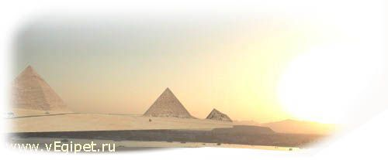

31.03.06 по 09.04.06 г. (10дн./9ноч.)
Отель, категория | ** | Пит | DBL | SGL | TRPL | CHD 0-6 | CHD 6-12 | HB/  ALL
HYATT REGENCY | 5* | BB | 1368 | 1760 | 1199 | 420 | 639 |   288
RITZ CARLTON | 5* | BB | 1359 | 1750 | 1310 | 420 | 420 | 225
LAGOUNA VISTA | 5* | ALL | 1049 | 1245 | 1021 | 420 | 420
Magic Life Sharm std | 5* | MAI | 1213 | 1360 | 1037 | 420 | 614 до 15
REEF OASIS | 5* | ALL | 1143 | 1388 | 1114 | 420 | 420
SOFITEL | 5* | BB | 932 | 1154 | 477 | 420 | 420 | 162
NOVOTEL | 5* | BB | 883 | 1095 | 863 | 420 | 420 | 162
RADISSON SAS | 5* | BB | 663 | 761 | 643 | 420 | 420 | 90
RADISSON SAS GOLDEN | 5* | ALL | 878 | 1015 | 859 | 420 | 420 | 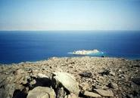
SHERATON main | 5* | BB | 1173 | 1466 | 1143 | 420 | 621 | 189
MARRIOTT BEACH | 5* | BB | 951 | 1147 | 899 | 420 | 512 | 180
CROWNE PLAZA | 5* | BB | 811 | 1007 | 791 | 420 | 420 | 135
TROPICANA GRAND OASIS | 5* | ALL | 945 | 1042 | 915 | 420 | 420
TROPICANA GRAND AZUR | 5* | ALL | 1051 | 1198 | 1022 | 420 | 420
SUNRISE ISLAND VIEW | 5* | ALL | 937 | 1199 | 908 | 420 | 420
SUNRISE ISLAND GARDEN | 5* | ALL | 839 | 1025 | 810 | 420 | 420
INTERCONTINENTAL | 5* | BB | 876 | 1072 | 857 | 420 | 420 | 180
SAVOY SHARM pool view | 5* | BB | 917 | 1113 | 888 | 420 | 420 | 162
IBEROTEL PALACE | 5* | HB | 927 | 1152 | 898 | 420 | 420 | 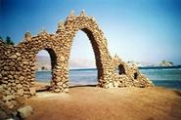
GRAND ROTANA DELUXE | 5* | BB | 849 | 1093 | 820 | 420 | 420 | 126
RENAISSANCE | 5* | BB | 799 | 1007 | 762 | 420 до 4 | 548 | 171
NAAMA BAY | 5* | HB | 868 | 1064 | 849 | 420 | 420
Domina Coral Bay Oasis | 5* | BB | 687 | 786 | 667 | 420 | 420 до 13 | 63
ROYAL PLAZA | 5* | HB | 705 | 826 | 686 | 420 | 420
CLUB EL FARAANA | 4* | ALL | 924 | 1071 | 895 | 420 | 420
PALMYRA RESORT | 4* | ALL | 741 | 859 | 722 | 420 | 521 до 14
SETI SHARM std | 4* | HB | 753 | 872 | 734 | 420 | 420 | 90
HOLIDAY INN | 4* | HB | 790 | 987 | 771 | 420 | 420
NORIA RESORT | 4+* | HB | 785 | 905 | 765 | 420 | 583
CORAL BEACH TIRAN | 4+* | HB | 761 | 908 | 741 | 420 | 420
ROSETTA | 4* | HB | 710 | 808 | 680 | 420 | 420
EL DIWAN | 3* | HB | 624 | 692 | 624 | 420 | 420 | 90
ZOUARA | 3* | HB | 604 | 683 | 585 | 420 | 420
FANTAZIA | 3* | HB | 640 | 738 | 620 | 420 | 420

В стоимость тура входит
: а/п СПб-Шарм-СПб, трансфер
, проживание,
питание.

Дополнительно оплачивается
: виза $15 с паспорта в а/п Шарм-Эль-Шейха,
страховка

