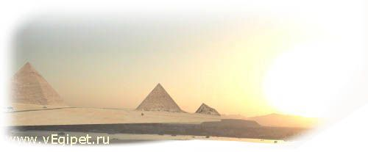
11.03.06 по 21.03.06 г. (11дн./10ноч.)

Отель, категория | ** | Пит | DBL | SGL | TRPL | CHD 0-6 | CHD 6-12 | HB/  ALL
HYATT REGENCY | 5* | BB | 1518 | 1958 | 1331 | 399 | 748 | 320
RITZ CARLTON | 5* | BB | 1353 | 1793 | 1298 | 399 | 399 | 250
LAGOUNA VISTA | 5* | ALL | 1100 | 1320 | 1067 | 399 | 399
Magic Life Sharm std | 5* | MAI | 1133 | 1210 | 990 | 399 | 399 до 15
REEF OASIS | 5* | ALL | 1168 | 1443 | 1135 | 399 | 399
SOFITEL | 5* | BB | 979 | 1221 | N/A | 399 | 399 | 180
NOVOTEL | 5* | BB | 893 | 1111 | 871 | 399 | 399 | 180
RADISSON SAS | 5* | HB | 913 | 1023 | 891 | 399 | 399
RADISSON SAS GOLDEN | 5* | ALL | 935 | 1089 | 913 | 399 | 399
SHERATON main | 5* | BB | 1254 | 1584 | 1221 | 399 | 550 | 210
MARRIOTT BEACH | 5* | BB | 968 | 1188 | 913 | 399 | 561 | 200
CROWNE PLAZA | 5* | BB | 847 | 1067 | 825 | 399 | 399 | 150
TROPICANA GRAND OASIS | 5* | ALL | 979 | 1089 | 880 | 399 | 399
TROPICANA GRAND AZUR | 5* | ALL | 1111 | 1276 | 1078 | 399 | 399
SUNRISE ISLAND VIEW | 5* | ALL | 999 | 1298 | 968 | 399 | 399
SUNRISE ISLAND GARDEN | 5* | ALL | 891 | 1100 | 858 | 399 | 399
INTERCONTINENTAL | 5* | BB | 899 | 1122 | 770 | 399 | 399 | 200
SAVOY SHARM pool view | 5* | BB | 979 | 1199 | 946 | 399 | 399 | 180
IBEROTEL PALACE | 5* | HB | 990 | 1243 | 957 | 399 | 399
GRAND ROTANA DELUXE | 5* | BB | 899 | 1177 | 869 | 399 | 399 | 140
RENAISSANCE | 5* | BB | 869 | 1089 | 825 | 399 | 399 | 190
NAAMA BAY | 5* | HB | 924 | 1144 | 902 | 399 | 399
Domina Coral Bay Oasis | 5* | BB | 693 | 792 | 671 | 399 | 399 до 13 | 70
ROYAL PLAZA | 5* | HB | 726 | 858 | 704 | 399 | 399
CLUB EL FARAANA | 4* | ALL | 957 | 1122 | 924 | 399 | 399
PALMYRA RESORT | 4* | ALL | 781 | 913 | 759 | 399 | 633 до 14
HOLIDAY INN | 4* | HB | 836 | 1056 | 814 | 399 | 399
NORIA RESORT | 4+* | HB | 783 | 917 | 761 | 399 | 583
CORAL BEACH TIRAN | 4+* | HB | 803 | 968 | 781 | 399 | 399
ROSETTA | 4* | HB | 737 | 847 | 704 | 399 | 399
EL DIWAN | 3* | HB | 649 | 726 | 649 | 399 | 399
ZOUARA | 3* | HB | 627 | 715 | 605 | 399 | 399
FANTAZIA | 3* | HB | 682 | 781 | 649 | 399 | 399
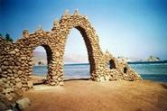
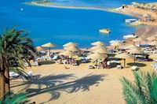
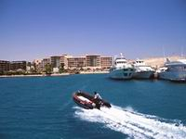
В стоимость тура входит: а/п СПб-Шарм-СПб, трансфер, проживание, питание.
Дополнительно оплачивается: виза $15 с паспорта в а/п Шарм-Эль-Шейха, страховка.

