 |  |  |  |  |  |  |  | 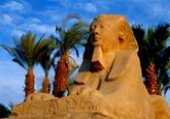
Cроки заезда: c 21 по 31 марта ( 11дней /10 ночей )
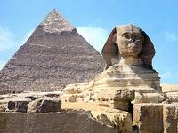 |  | DBL | SGL | EXB | CHD 1й |  | CHD 2-й
BEIRUT |  | 680 | 780 | 660 | 490 |  | 570
3*+ HB (ALL 8$ в день) |  |  |  |  |  |  | 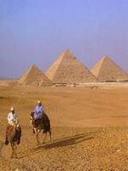
CORAL BEACH |  | 750 | 860 | 730 | 490 |  | 600
4* HB (FB - 9$), SV 5$
BELLA VISTA |  | 720 | 810 | 710 | 490 |  | 590
4* HB
SEA GULL |  | 760 | 890 | 740 | 490 |  | 610
4*+ HB (ALL 9$ )
LE MERIDIEN (standart) |  | 790 | 950 | 760 | 490 |  | 610
5* HB 10$ - all |  |  |  |  |  |  | 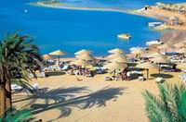
GOLF |  | 550 | 600 | 540 | 490 |  | 520
2* HB
EL SAMAKA CLUB |  | 670 | 750 | 650 | 490 |  | 570
3* HB ( ALL 11 $ )
LE PASHA |  | 860 | 1010 | 830 | 490 |  | 650
4* ALL
SULTAN BEACH |  | 690 | 790 | 680 | 490 |  | 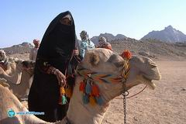  570
4* HB (ALL 10$)
LILLILAND |  | 790 | 890 | 770 | 490 |  | 620
4* HB (ALL 10$)
SINDBAD AQUA |  | 700 | 750 | 690 | 490 |  | 580
4* HB (ALL 9 $)
ALI BABA |  | 1030 | 1130 | 1010 | 490 |  | 740
4* ALL
REGINA STYLE |  | 780 | 880 | 760 | 490 |  | 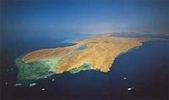  670
4* HB (ALL 10 $)
TITANIC Aqua Park |  | 970 | 1070 | 950 | 490 |  | 710
4* ALL
CLUB GOLDEN 5 |  | 900 | 1090 | 880 | 490 |  | 770
4+* HB ( ALL 10 $ )
SOFITEL |  | 895 | 1070 | * | 490 |  | *
4* + HB |  |  |  |  |  |  | 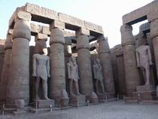
GRAND AZUR HORISONT |  | 980 | 1090 | 930 | 490 |  | 700
5*ALL
SUNRISE GARDEN BEACH |  | 1200 | 1450 | 1170 | 490 |  | 810
5* UALL
В стоимость тура не входит: страховка (0,7$/сутки),
виза 15$ в аэропорту

