 |  |  |  |  |  | 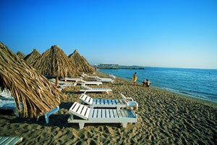
Сроки заезда: 4, 11, 18 марта - 1 и 2 недели
 |  | DBL | SGL | EXB | 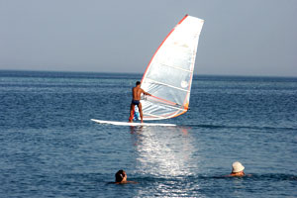  CHD 1й
 |  | ГАРАНТИРОВАННЫЕ ОТЕЛИ
BEIRUT |  | 560 | 630 | 545 | 390
3*+ HB (ALL 8$ в день) |  | 675 | 810 | 640 | 390
CORAL BEACH |  | 610 | 680 | 590 | 390
4* HB (FB - 9$), SV 5$ |  | 760 | 912 | 730 | 390
BELLA VISTA |  | 580 | 640 | 570 | 390
4* HB |  | 720 | 840 | 715 | 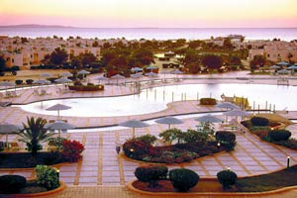  390
SEA GULL |  | 610 | 705 | 600 | 390
4*+ HB (ALL 9$ ) |  | 770 | 955 | 745 | 390
LE MERIDIEN (standart) |  | 630 | 735 | 610 | 390
5* HB 14$ - all |  | 790 | 1010 | 750 | 390
GOLF |  | 460 | 495 | 455 | 390
2* HB |  | 500 | 570 | 490 | 390
EL SAMAKA CLUB |  | 545 | 600 | 530 | 390
3* HB ( ALL 11 $ ) |  | 650 | 760 | 620 | 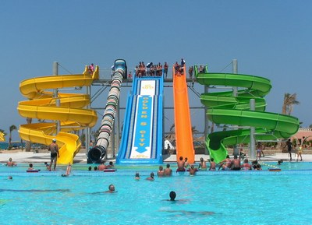  390
LE PASHA |  | 670 | 780 | 660 | 390
4* ALL |  | 895 | 1120 | 870 | 390
SULTAN BEACH |  | 555 | 630 | 545 | 390
4* HB (ALL 8$) |  | 670 | 800 | 640 | 390
LILLILAND |  | 625 | 695 | 610 | 390
4* HB (ALL 10$) |  | 800 | 940 | 770 | 390
SINDBAD AQUA |  | 570 | 605 | 560 | 390
4* HB (ALL 9 $) |  | 700 | 770 | 670 | 390
TITANIC Aqua Park |  | 750 | 820 | 735 | 390
4* ALL |  | 1050 | 1190 | 1020 | 390
ALI BABA |  | 790 | 860 | 770 | 390
4* ALL |  | 1130 | 1270 | 1105 | 390
REGINA STYLE |  | 625 | 695 | 610 | 390
4* HB (ALL 10 $) |  | 800 | 940 | 770 | 390
CLUB GOLDEN 5 |  | 640 | 730 | 625 | 390
4+* НВ |  | 830 | 1010 | 800 | 390
SOFITEL |  | 710 | 840 | * | 390
4* + HB |  | 970 | 1220 | * | 390
GRAND AZUR HORISON |  | 730 | 800 | 700 | 390
5*ALL |  | 1060 | 1220 | 990 | 390
SUNRISE GARDEN BEACH |  | 930 | 1100 | 910 | 390
5* UALL |  | 1370 | 1720 | 1330 | 390
В стоимость тура не входит:
страховка (0,7$/сутки), виза 15$ в аэропорту

