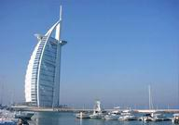
19.02 -01.03.2006 11 дней / 10 ночей
ОТЕЛЬ | ½ DBL | SNGL | TRPL | 3-й реб. | 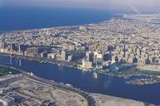  Допл за питан.
ДУБАИ
GALAXY PLAZA HOTEL 1*, HB | 810 | 930 | 810 | 670 | 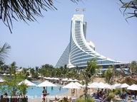  -
DEIRA PARK HOTEL 2*, FB | 870 | 1040 | n/a | 700 | -
DUBAI PALM HOTEL 3*,HB | 950 | 1210 | 820 | 630 | -
K porte inn Dubai 3*, HB | 990 | 1300 | 900 | 670 | -
Landmark 3*, BB | 1020 | 1310 | 810 | 605 | 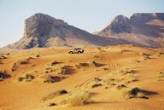  120/50
Regent Beach Resort 3*, BB | 1370 | 1960 | 920 | 620 | -
Flora Grand Hotel 4*, BB | 1210 | 1630 | 920 | 620 | 150/70
Metropolitan Deira 4*, BB | 1240 | 1670 | 930 | 670 | 100
JEBEL ALI GOLF RES & SPA 5*, BB GOLF.V. | 1920 | 2560 | n/a | 1000 |   340/170
Hilton Dubai Jumeirah, 5*, BB, SV | 2190 | 3330 | 1180 | 730 | 390/195
Sheraton Jumeirah Beach Resort & Towers Dubai 5*, BB Prefferd Sea View | 2220 | 3460 | 1560 | 740 | 280/140
Le Royal Meridien Beach Resort & Spa Deluxe Sea View 5*, HB | 2750 | 4400 | 1510 | 890 | 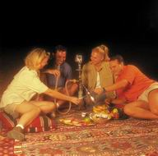  -
DUBAI MARINA BEACH 5*, BB, STD SUITE | 2320 | 4180 | 1240 | 800 | 370/190
 | 3170 | 4720 | 1240 | 800 | 370/190
ШАРДЖА
Golden Beach Motel 3*, HB | 1080 | 1280 | 890 | 700 | 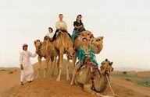  -
BEACH HOTEL 3*, HB | 1220 | 1510 | 1000 | 980 | -
SHARJAH CARLTON 4*, HB, CV | 1260 | 1450 | 1100 | 740 | -
Grand Hotel - Sharjah 4*, BB, CV | 1390 | 1850 | 970 | 700 | 180/120
RADISSON SAS RESORT 4*,BB,std | 1350 | 1860 | 1120 | 710 | 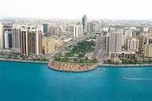  220/110
AJMAN
CORAL SUITES 4*, BB Deluxe Room | 1070 | 1420 | 860 | 570 | 120/60
AJMAN KEMPINSKI HOTEL & RESORT 5*, BB Deluxe Room | 2010 | 3050 | 1430 | 740 | 330/165
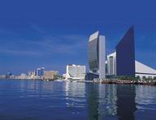
UMM Al QWAIN
Umm Al Qwain Beach Hotel, 4*, BB ВОЗМОЖНО ALL INC | 1050 | 1480 | 890 | 730 | 80/40
RAS AL KHAIMAH
BIN MAJID BEACH 3*, BB ВОЗМОЖНО ALL INC | 935 | 1155 | 855 | 620 | 150/70
Bin Majid Beach Resort , 4*, BB Chalet | 1080 | 1410 | 850 | 640 | 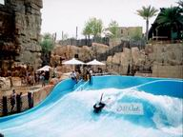  150/70
The Oceanic Hotel - Khorfakkan 4*, BB | 1160 | 1425 | 1020 | 680 | 220/100

В стоимость входит:
перелет, трансфер, проживание, питание.
Дополнительно оплачивается: виза 42 у.е., срочная 70 у.е., страховка.

